Project Design Phase-II
Data Flow Diagram & User Stories

Date | 07 July 2026
Team ID
Project Name | shopEZ-MERN E-commerce Application
Maximum Marks | 4 Marks

Data Flow Diagrams:
A Data Flow Diagram (DFD) is a traditional visual representation of the information flows within a system. A neat and clear DFD can depict the right amount of the system requirement graphically. It shows how data enters and leaves the system, what changes the information, and where data is stored.

Example:
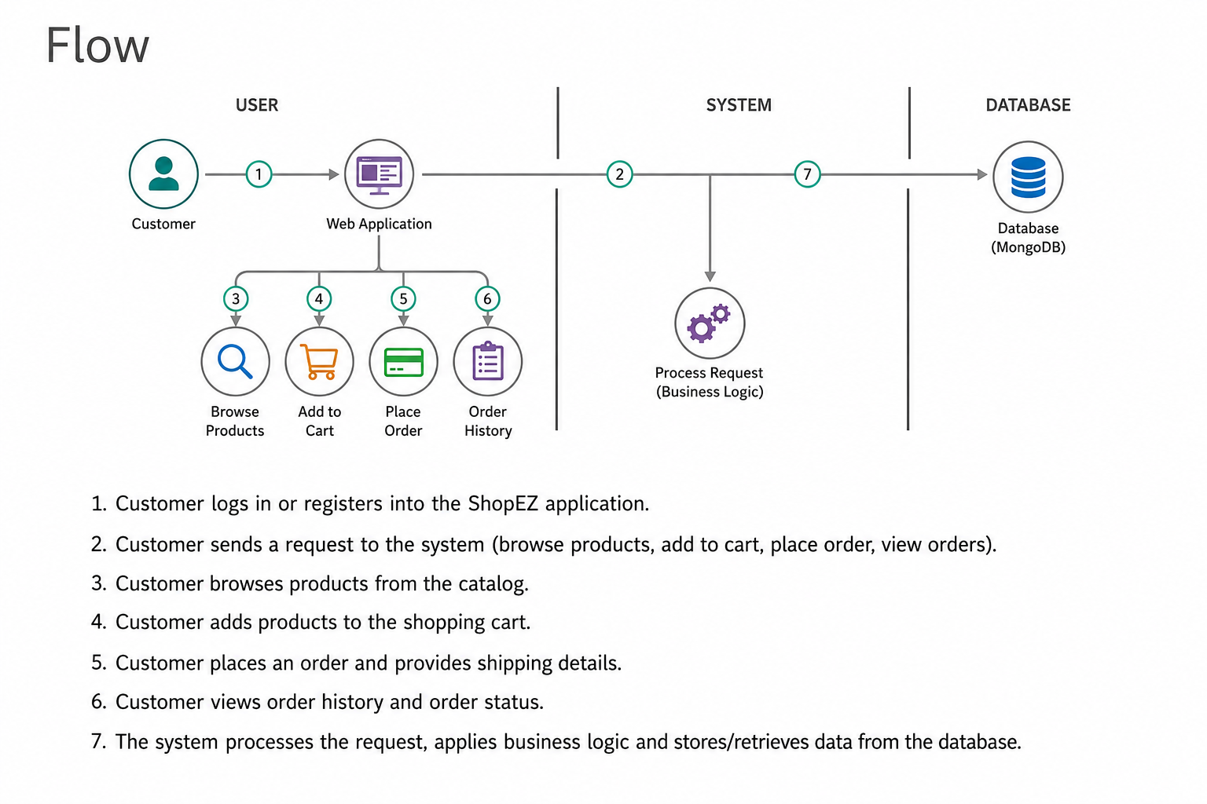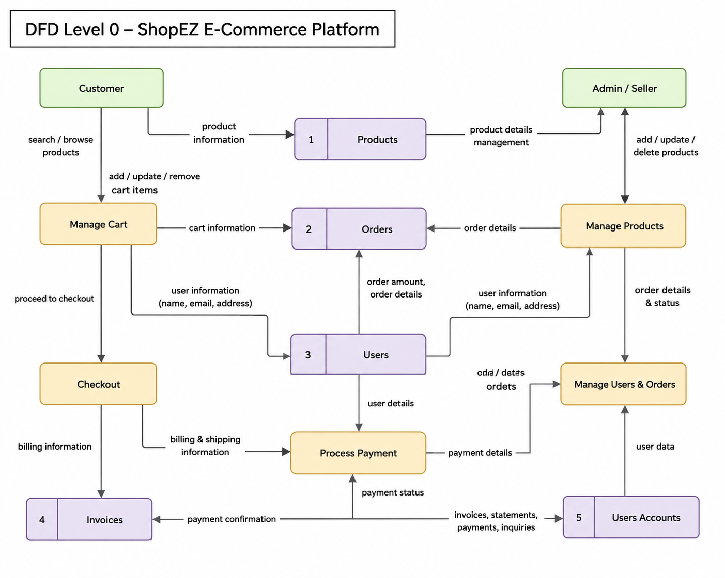

User Stories:
User Type | Functional Requirement (Epic) | User Story Number | User Story / Task | Acceptance criteria | Priority | Release
Customer (Web User) | User Authentication | USN-1 | As a customer, I can register using my name, email and password. | User account is created successfully and login is possible. | High | Sprint-1
Customer (Web User) | Login | USN-2 | As a user, I can login using my email and password. | User is redirected to the home page after successful login. | High | Sprint-1
Customer (Web User) | Product  Browsing | USN-3 | As a customer, I can view all available products. | Products are displayed with images, price and details. | High | Sprint-2
Customer (Web User) | Shopping Cart | USN-4 | As a customer, I can add and remove products from my cart. | Cart updates correctly with selected products. | Medium | Sprint-3
Customer (Web User) | Wishlist | USN-5 | As a user, I can add or remove products from my wishlist | Wishlist is updated successfully | High | Sprint-3
Customer (Web User) | Order Management | USN-6 | As a customer, I can place an order using Buy Now or Cart. | Order is created successfully and visible in My Orders. | Medium | Sprint-4
Customer (Web user) | My Orders | USN-7 | As a customer, I can view my previous orders. | Order history is displayed correctly. | High | Sprint-4
Administrator | Category Management | USN-8 | As an admin, I can create, update and delete categories. | Categories are managed successfully. | High | Sprint-5
Administrator | Product Management | USN-9 | As an admin,I can manage products | Products can be added, edited and deleted. | High | Sprint-5
Administrator | Order Management | USN-10 | As an admin,I can update customer order status | Order status changes are reflected successfully. | High | Sprint-6

